**Asignment –8**

**Formatting Query output.**

1. **Assume each salesperson has a 12% commission. Write a query on the orders table that will produce the order number, the salesperson number, and the amount of the salesperson’s commission for that order.**

mysql> select onum,

-> Snum,

-> amt,

-> (amt*12)/100 commision

-> from orders;

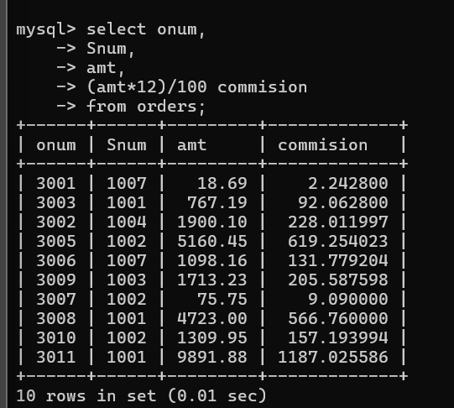

1. **Write a query on the Customers table that will find the highest rating in each city. Put the output in this form: For the city (city), the highest rating is : (rating).**

mysql> select concat('for the city ', city , ' the highest rating is ' , MAX

(Rating)) As Result

-> from customers

-> group by city;

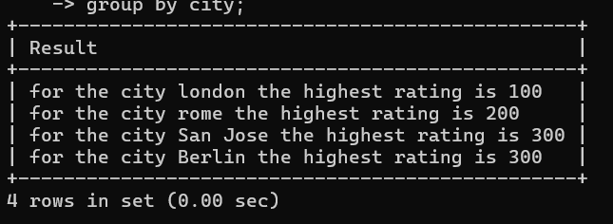

1. **Write a query that lists customers in descending order of rating. Output the rating field first, followed by the customer’s name and number.**

mysql> select rating,

-> cname,

-> Snum

-> from customers

-> order by rating DESC;

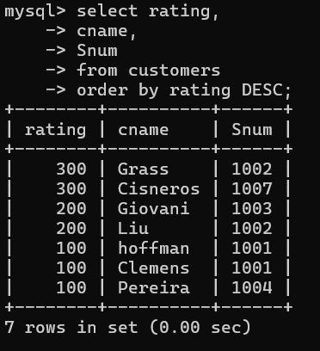

1. **Write a query that totals the orders for each day and places the results in descending order.**

mysql> select count(odate) total_orders,

-> odate

-> from orders

-> group by odate

-> order by total_orders DESC;

